  - System diagram (take system_diagram_verification.png from 11-4-26 code folder):
    - 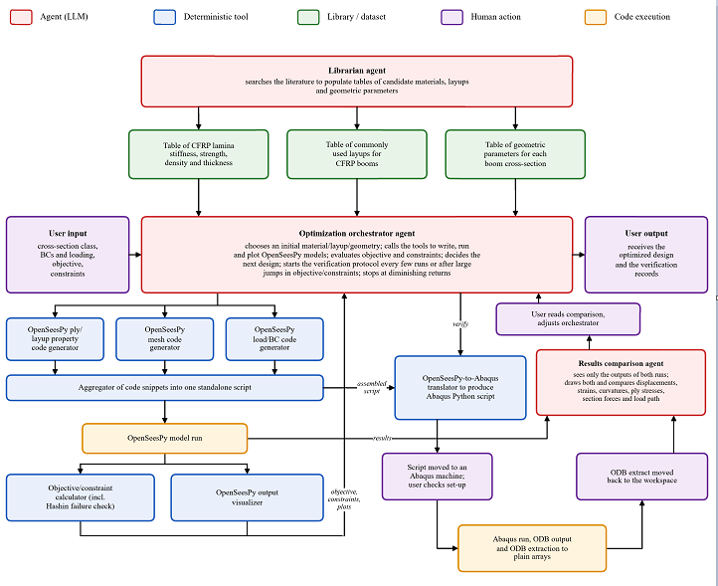
    - On the slide, put in the title that all modules have been built and tested, including the agents
- For each component: Put screenshot of the component being tested, describe what that component does, screenshot of prompt given, screenshot of output provided, say it’s working and any failure cases
  - Each of the catalogs (leave these as placeholders for now):
    - Screenshot of the corresponding green box in the system diagram
    - Screenshot of Federico’s prompt to create the catalog
    - Table with a few sample lines from each catalog
  - OpenSeesPy write/run pipeline:
    - Screenshot of bottom left quadrant of system diagram
    - Explain what this part of the system does: Writes and runs OpenSeesPy code, evaluates objective and constraints to feed back into orchestrator, visualizes output so user can understand it
    - Screenshot of prompt to demonstrate FEA code generation, run, and analysis for 1 tape spring:
      - 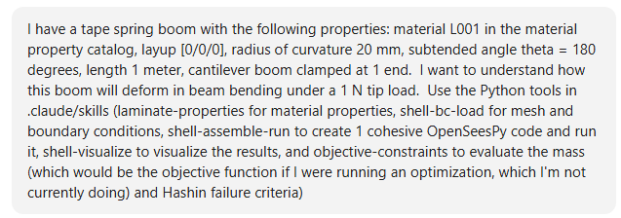
    - Say we can’t really take a screenshot of the full OpenSeesPy code generated by the 1st few tools and put it on a single slide, so only displaying outputs
    - Screenshot of output (tip deflection and rotation, comparison to beam theory to show this is accurate, mesh convergence study):
      - 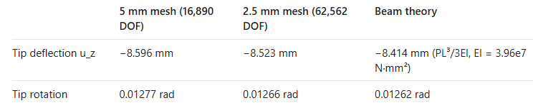
    - Screenshot of objective/constraint check:
      - 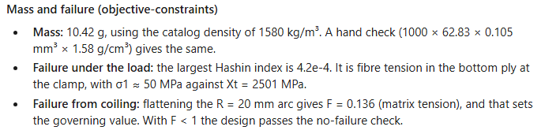
    - Screenshot of visualization:
      - Axial stresses on top ply due to bending:
        - 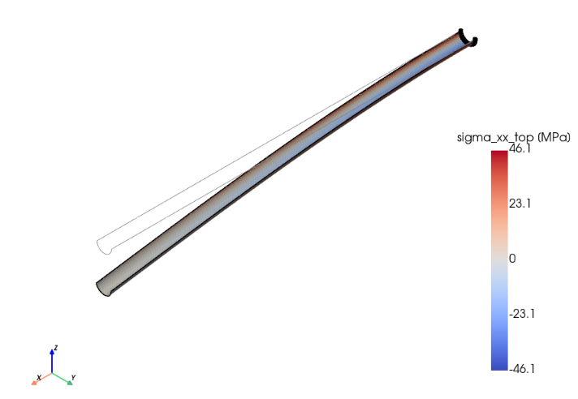
      - Transverse deflection (drawing exaggerated 11.7x, numbers on colorbar are correct):
        - 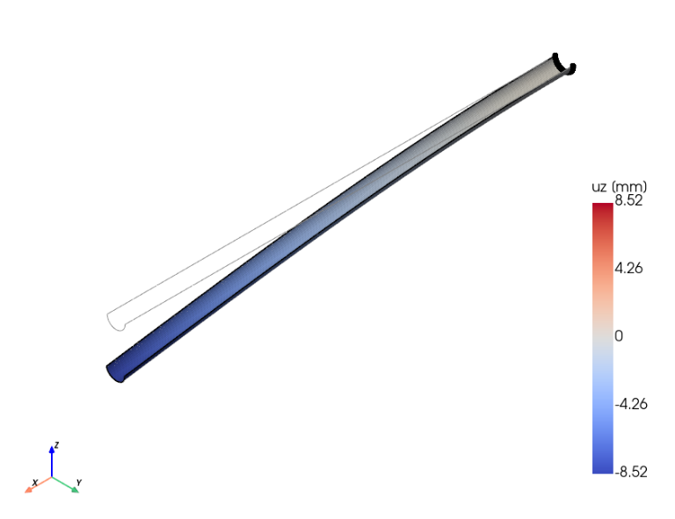
  - Abaqus verification loop:
    - Screenshot of bottom right quadrant of system diagram:
    - Explain what this part of the diagram does: Translates OpenSeesPy code to Abaqus, which Claude can now run because we put our GitHub repository on our lab server. Then takes Abaqus output and OpenSeesPy output and uses independent agent that only sees the 2 outputs to verify that they agree and discuss any discrepancies
    - Screenshot of prompt (note that we need to be a bit careful with running Abaqus on our lab servers with Claude to make sure it doesn’t take over the server CPU or start modifying files outside our GitHub repository:
      - 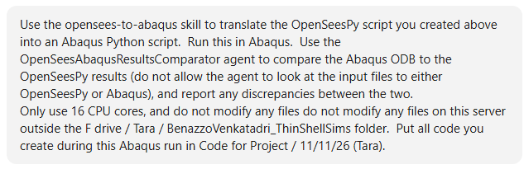
    - Screenshots of results:
      - 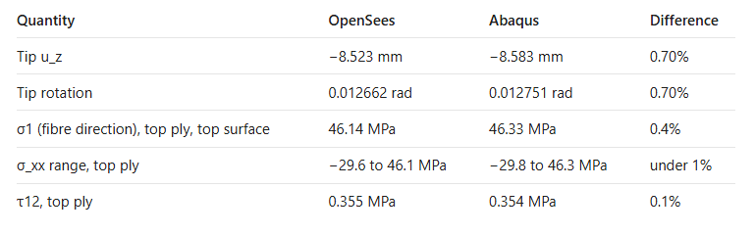
        - Error is acceptable given that Abaqus and OpenSeesPy model shell elements, multi-layer composites, and loads/BCs differently
      - 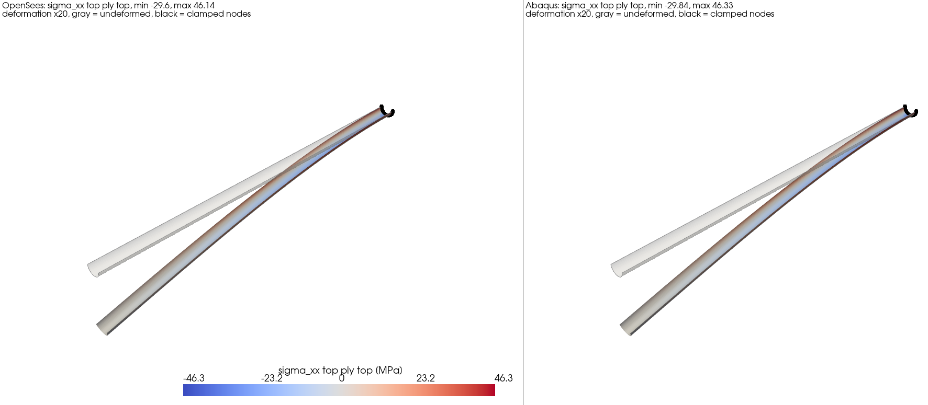
      - 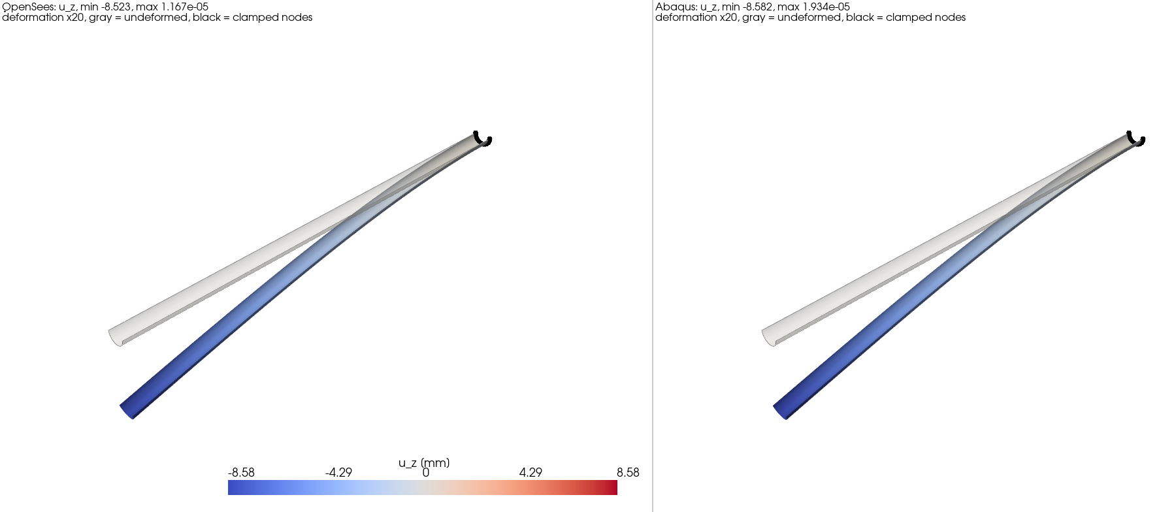
- Full demo of baseline comparison
  - Goal: Demonstrate that full orchestrator system works for a subset of materials, layups, and geometries, and that it comes up with the optimal solution that a human knows to be optimal
  - Explanation of creation of sandboxed options for optimization orchestrator:
    - Prompt:
      - 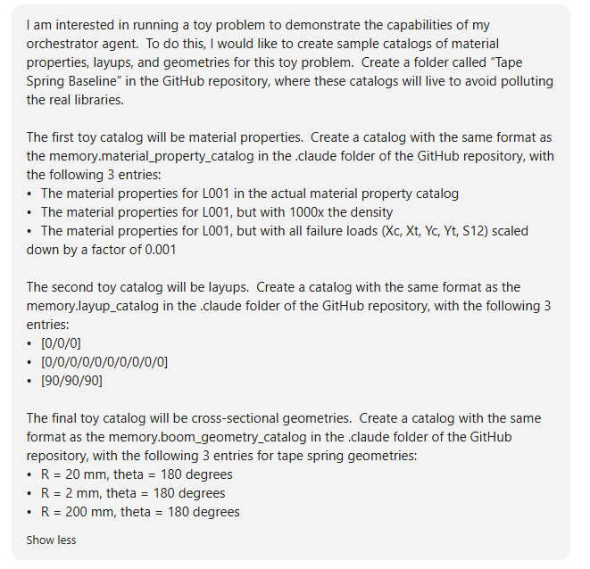
    - Materials:
      - Normal CFRP material L001
      - Same CFRP material but 1000x the density (so it won’t be the optimal from a mass perspective)
      - Same CFRP material but 0.001x the failure stresses (so we will induce material failure and not satisfy constraints)
      - Output:
        - 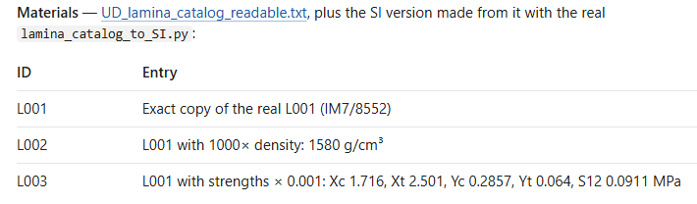
    - Layups:
      - [0/0/0] (should be the optimal one, since we are only inducing axial loads and shouldn’t need off-axis plies)
      - [0/0/0/0/0/0/0/0/0/0] (will be way too thick, definitely increasing mass and potentially running into issues with failure stresses)
      - [90/90/90] (not nearly enough strength in the longitudinal direction, will not satisfy constraints)
      - Output:
        - 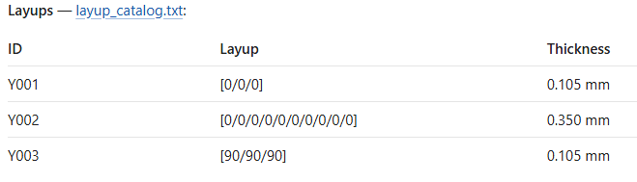
    - Geometries:
      - R = 20 mm, theta = 180 degrees (should be optimal)
      - R = 2 mm, theta = 180 degrees (very tight curvature, will likely induce material failure during coiling)
      - R = 200 mm, theta = 180 degrees (will increase mass substantially, likely not to be optimal)
      - Output:
        - 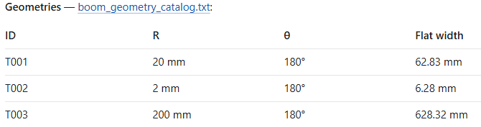
  - Optimization setup:
    - Objective: Find a boom with minimum mass
    - Constraints:
      - Tape spring cross section
      - 1 meter length
      - Cantilever boom (clamped at one end, free at the other)
      - Must withstand an axial extension load of 10 N without material failure
      - Must withstand a transverse tip load of 1 N in opposite-sense bending with a maximum tip deflection of 2 cm and no material failure
      - Must coil around a hub with a 4 cm radius without material failure
  - First, run OpenSeesPy pipeline of deterministic tools to get key results for known optimal design without introducing agents. This is the baseline we are trying to demonstrate that our orchestrator can achieve:
    - Prompt:
      - 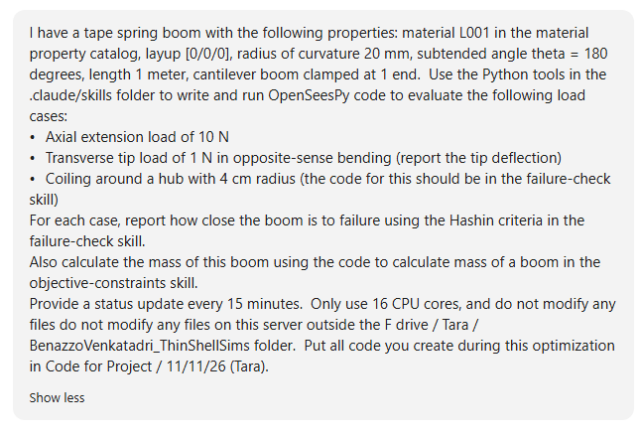
    - Results:
      - 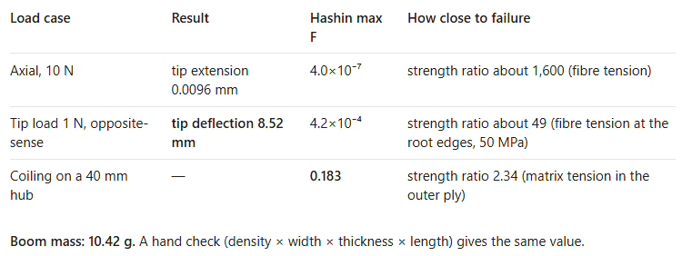
  - Now run optimization:
    - Prompt:
      - 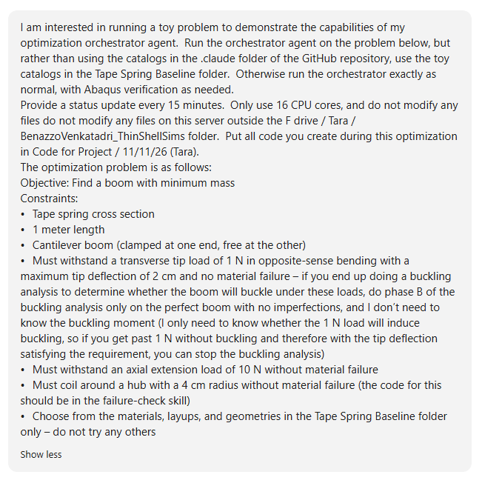
    - Results: Optimal design is the same as human-chosen baseline, all major quantities agree (within slight error likely induced by different mesh sizes) with baseline, Abaqus verification also agrees with quantities that it calculates within reasonable error
      - 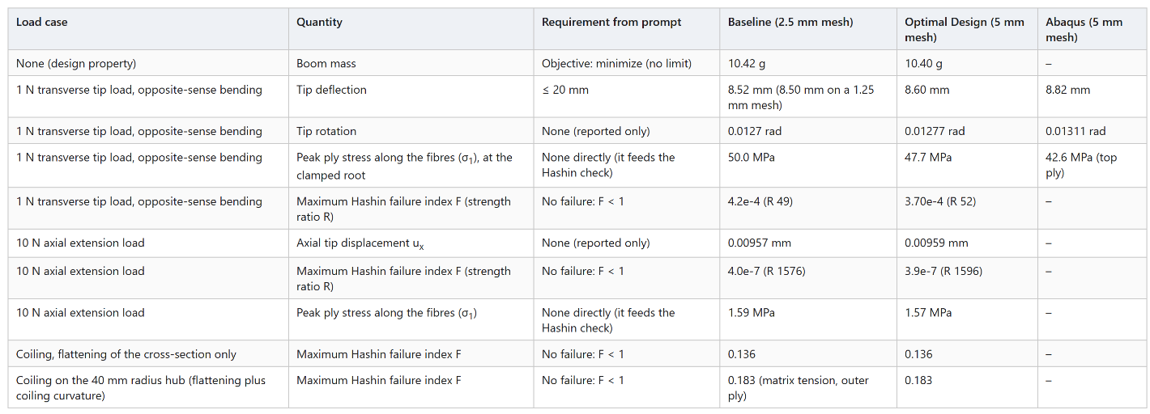
    - Also discuss how Claude ruled out certain designs out of the 27 possible ones by running pre-tests and discovering that they would not pass material failure tests, which sped up the optimization by significantly reducing the number of required iterations
    - Thus, our full optimization-orchestrator architecture works as intended
    - Next step: Go beyond the baseline to solve optimization problems a human wouldn’t be able to do – far more materials/layups/geometries, all of them reasonable (not like the altered results here), so it would take a human an unreasonably long time to do the optimization but the orchestrator can do it much faster
  - Failure case: Attempt to re-create Palmeri and Laurenzi (2024) omega boom geometry optimization results. This was originally considered as a way to test against a baseline, but ended up being outside the scope of the optimization orchestrator (involved user-input material/layup rather than relying on catalogs, continuous optimization of geometry instead of discrete values in catalog, involved different buckling simulations than skills previously set up). Claude worked for hours to try and replicate results, but could not even get a mesh convergence study to work on the solution the paper found to be optimal because of OpenSeesPy’s limitations on buckling simulation capabilities, so this was abandoned in favor of the simpler baseline explained on the prior slide
      - Prompt:

